Task Catalyst

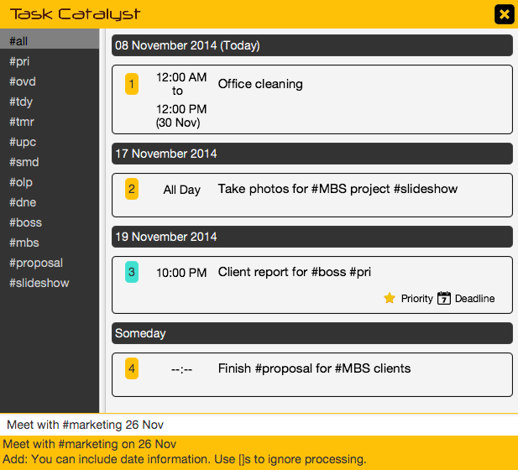

**Supervisor**: Yeow Kai Yao **Extra feature**: Natural Bucket

|  |  |  |  |
| --- | --- | --- | --- |
| Kelvin  Ang Kah Min, Kelvin  **Project Team Leader Code Quality Integration** Testing | Zhenyu  Toh Zhen Yu  **CS2101 Team leader Documentation** Code Quality Testing | Thida  Lin XiuQing, Thida  **Scheduling and Tracking Resource Acquisition** Testing Integration | Lim Wei Jie  **Testing** Code Quality Resource Acquisition Integration |

# Vision

Task Catalyst is a lightweight and simple task manager that aims to provide a natural user experience, serving as a catalyst between the user and their tasks.

Audience  
Task Catalyst caters to the modern urban crowd with a busy lifestyle. The program is optimized for keyboard-use, and hence provides for many command styles (UNIX, DOS, plain English, etc.) and uses familiar features like hashtagging for organization.User guide

## **Main Interface**

Task View

Command  
Bar

Default Hashtags

Hashtags

User Hashtags

Hashtags

Status and Help Bar

Hashtags

Settings and Exit button

Hashtags

## Screenshot 2014-11-08 14

The Settings Button will launch the settings window and the Exit Button will close the program.

The Task View is where tasks are displayed. It changes accordingly to category, hashtags and search term.

The Command Bar is where commands are entered. It is the main mode of operating the software.

The Default Hashtags contain categories that tasks are grouped into by default. Below is an explanation of what they mean:

#all – All Tasks

#pri – Priority Tasks

#ovd – Overdue Tasks  
#tdy – Today’s Tasks  
#tmr – Tomorrow’s Tasks  
#upc – Upcoming Tasks

#smd – Someday Tasks

#olp – Overlapping Tasks  
#dne – Done Tasks

The User Hashtags section displays hashtags used by the user when adding tasks. They can be quickly used to organize tasks.

The Status and Help Bar displays helpful context-sensitive hints and status messages for your actions.

## **Adding a Task**



Adding a task is as simple as typing it into the command bar. **You do not have to follow strict formats,** as the program naturally understands date and time.

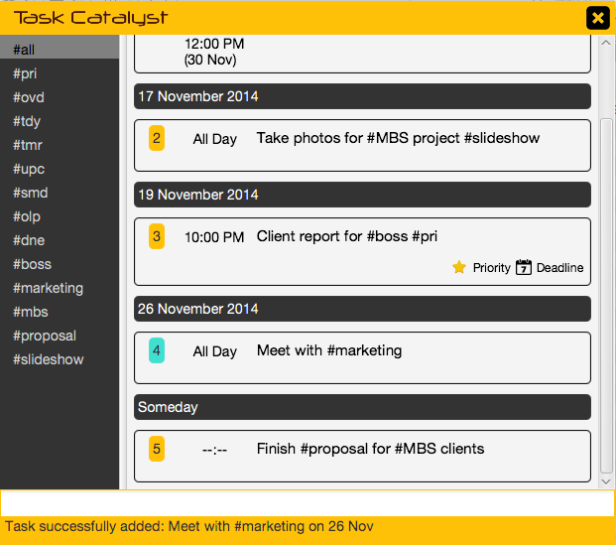

You can make use of the **hashtagging** feature to organize your tasks. When hashtags are specified, they appear in the hashtag list at the left.

The recent added task will be highlighted in cyan color.

The Status and Help Bar displays the successful message after you add a task.

## **Adding a Task with alternative timing**

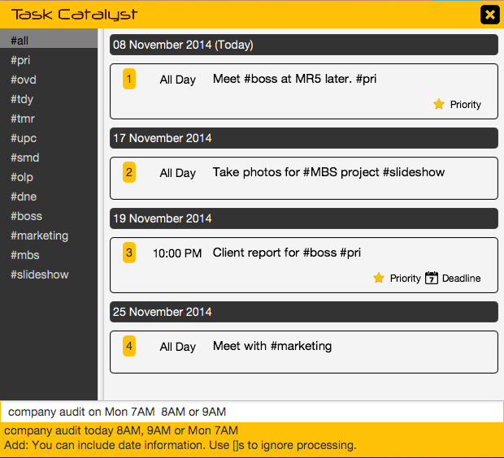

You can add a task with alternative timing as shown.

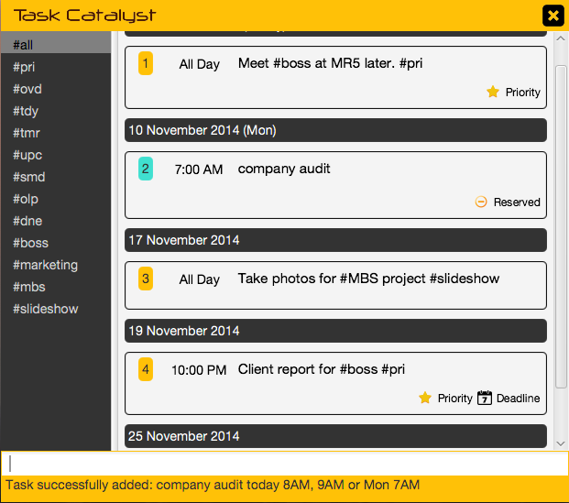

The task will be tagged with “Reserved” icon.

## **Adding a Task with different timings**

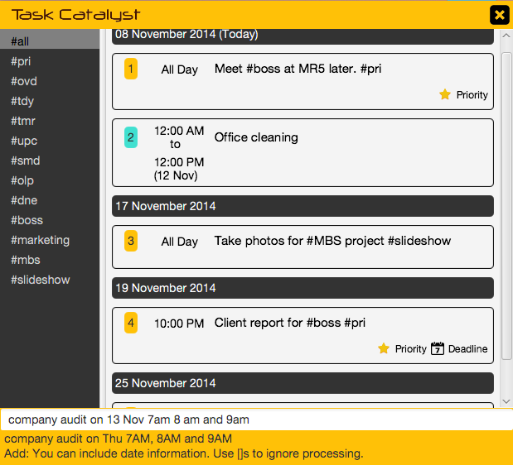

You can add a task with different timings as shown.

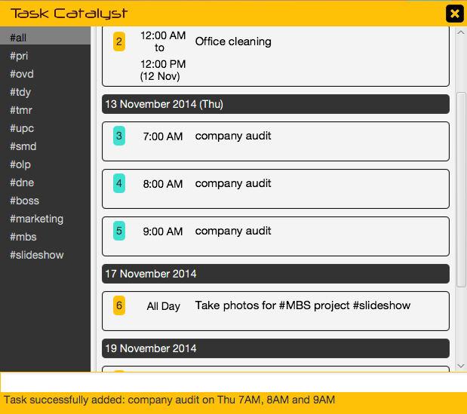

The same description of task with different timings is added repeatedly according to the timings.

## ***Working with Hashtags***

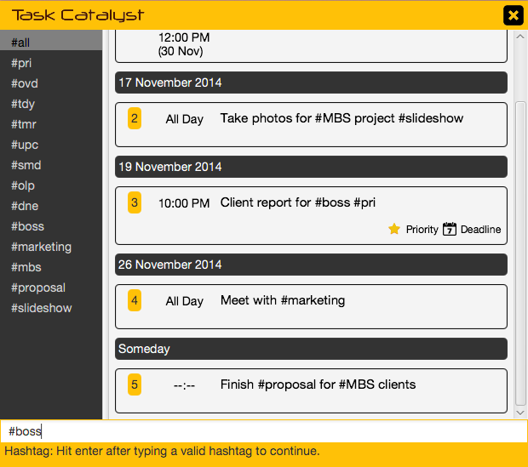

You can quickly navigate through categories or custom hashtags simply by typing the hashtag in the command bar.

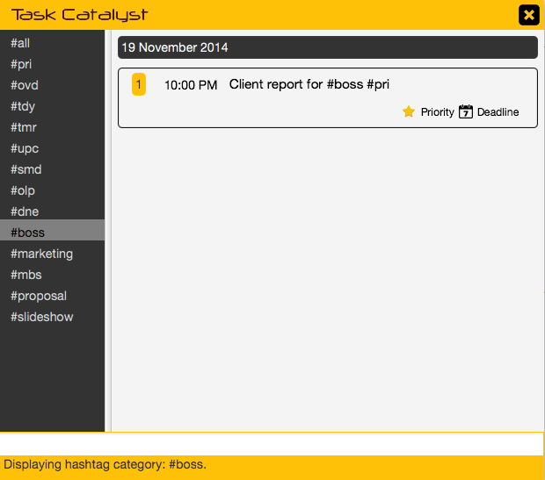***Searching for Tasks***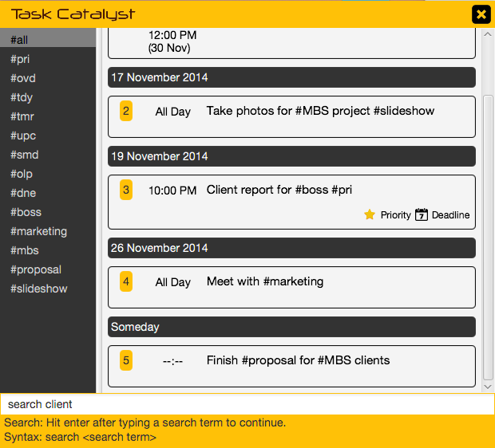

This will display the corresponding items with the hashtag. Notice that the selected hashtag is highlighted***.***

You can also search for tasks typing “search”, or alternative commands, followed by a search keyword.

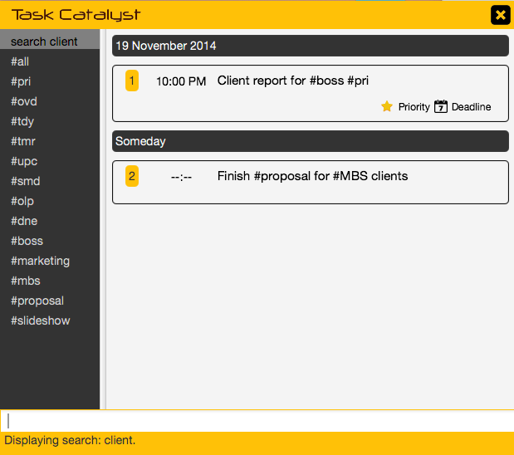

Matching items are quickly displayed in the task view.

## Editing a Task

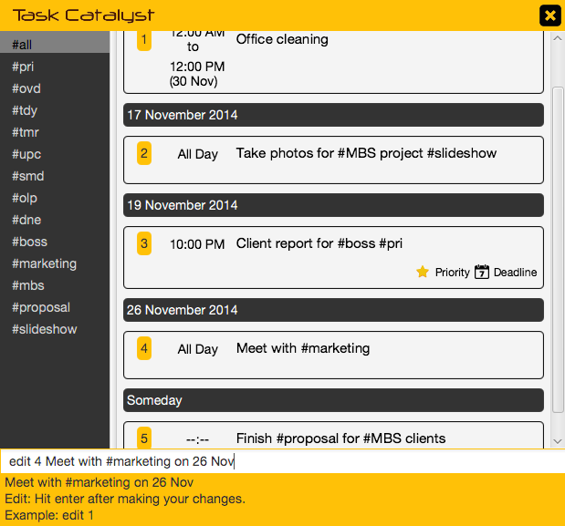

You edit a task simply by typing “edit”, or alternative commands, followed by the task number.

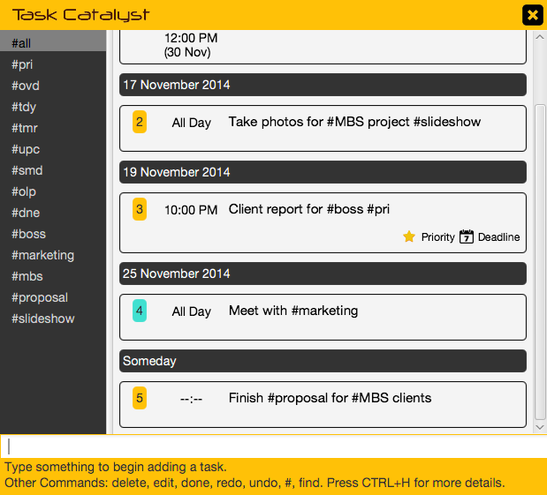

This will move your cursor focus to the task where you can make your changes. Simply hit ENTER to save the changes.

## Completing a Task

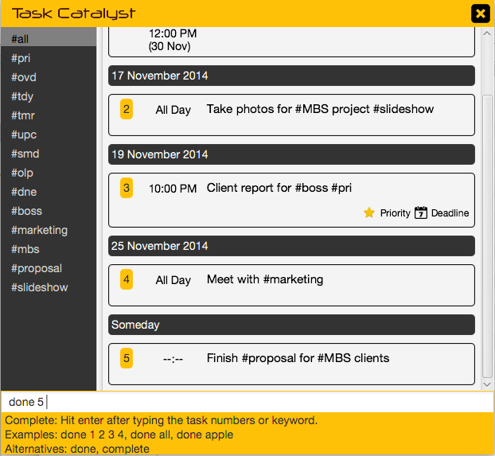

You can complete a task simply by typing “done” or “complete”, or alternative commands, followed by the task number or keyword.

You can also mark all tasks as done by typing “done all”.

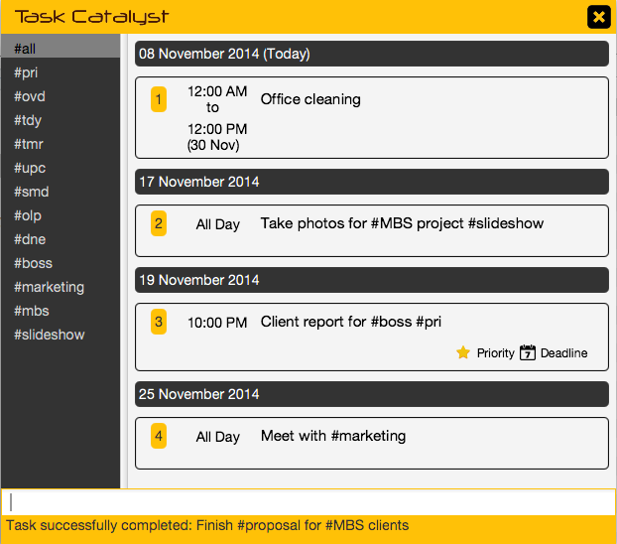

The specified task is moved into the #dne list and will no longer show up in other categories.

## Deleting a Task

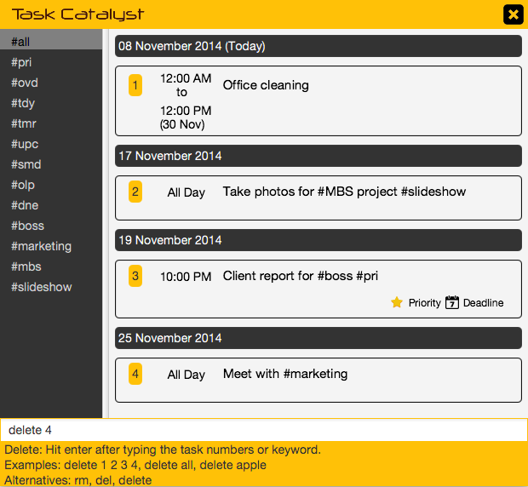

You can delete an unwanted task simply by typing “delete”, or alternative commands “rm, del”, followed by the specific task number or numbers.

You can also delete all tasks by typing “delete all”.

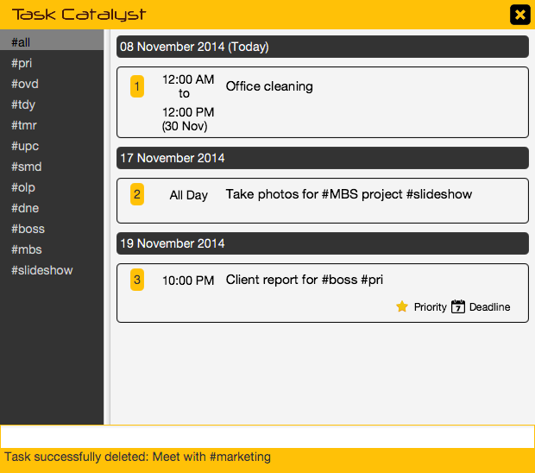

The item is deleted and removed from display.

## Undoing an Action

## Macintosh HD:Users:linxiuqing:Dropbox:Screenshots:Screenshot 2014-11-08 16.33.41.png

You may undo an action by typing “undo” or **Ctrl+Z**.

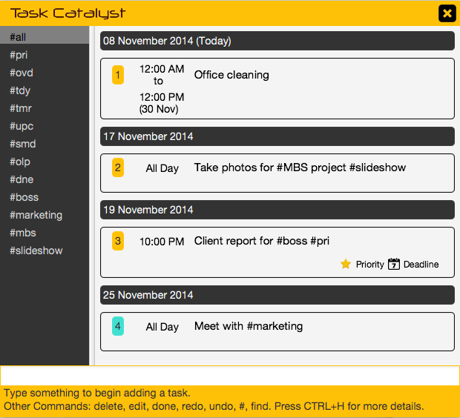

The previous action is undone. You may also redo by typing “redo” or **Ctrl+Y**.

## Setting Priority Task

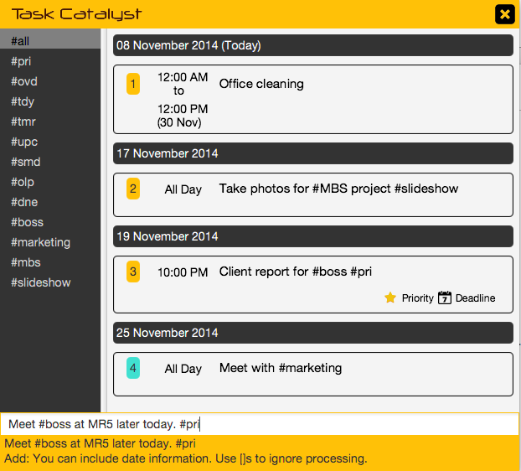

You can set priority by hashtagging an entry with **#pri** at the end of description.

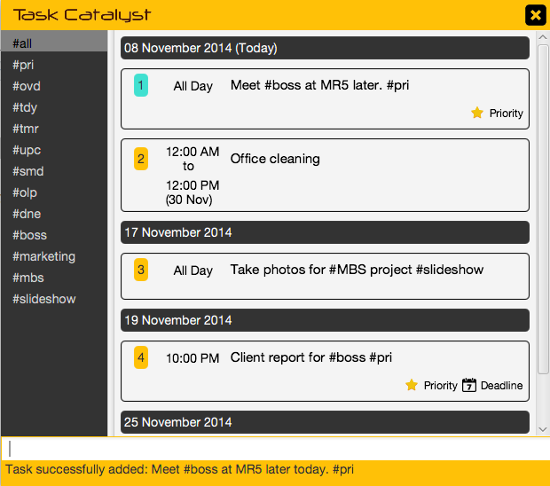

The task is tagged with Priority icon and also put in “**#pri**” category.

You can type “**#pri**” to view the task.

## Hotkey Summoning

You can summon the program using some global hotkeys to execute a specific action. You can use Ctrl+H to launch comprehensive quick guide menu. The defined hotkeys are as the following.

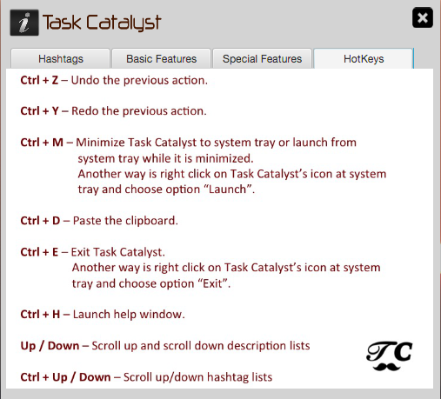

## Smart Paste

You can quickly paste highlighted text from other applications using a global hotkey Ctrl+D.

Appendix A: User stories.

## Likely

|  |  |  |
| --- | --- | --- |
| ID | I can … (i.e. Functionality) | so that I … (i.e. Value) |
| Basic Add | I can add tasks to the program | so that the program can manage my TODO for me. |
| Date and/or Time | I can specify date and/or time when adding tasks, | so that I can keep track of the tasks. |
| Display Tasks Chronologically | I can view tasks in chronological order, | so that I know the upcoming tasks. |
| Mark As Done | I can mark tasks that are done, | so that I can view the outstanding tasks. |
| Edit Tasks | I can edit my tasks, | so that I can make changes where necessary. |
| Delete Tasks | I can delete a task |  |
| Undo / Redo | I can undo or redo an action, | so that I can revert any unwanted changes. |
| Alternative Commands | I can make use of different keywords to represent the same command, | so that I can use what's most natural to me. |
| Date Range | I can specify a date range for my tasks, | so that I do not have to add multiple tasks to cover the range. |
| Deadline Categories | I can view tasks that are sorted into different deadline categories (today, tomorrow, upcoming), | so that I can better organize my tasks. |
| Hashtag Marking | I can make use of hashtags, | so that I can mark important keywords. |
| Hashtag Retrieve | I can retrieve tasks marked by a hashtag, | so that I can view related tasks. |
| View Done History | I can view my task history, | so that I can review what I've completed. |
| Flexible Date/Time Format | I can use many different formats for date and time, | so that I can use what is natural to me. |
| Overlap Notification | I am notified when I have overlapping tasks, | so that I know if I need to reschedule tasks. |
| Priority | I can set priority to tasks, | so I know what to do first. |
| Reminder | I can set reminders for tasks, | so that I will not miss my appointments. |
| Delete/Done Multiple Tasks | I can select multiple tasks to delete or complete, | so that it will speed up my workflow. |
| Shortcut Keys to Summon | I can make use of global shortcut keys to summon the program, | so that I do not have to use the mouse for that. |
| Shortcut Keys to Paste | I can quickly add items from another application (i.e. Email Client, Web Browser) into my TODO using hotkeys, | so that it speeds up my workflow. |

## Unlikely

|  |  |  |
| --- | --- | --- |
| ID | I can … (i.e. Functionality) | so that I … (i.e. Value) |
| Email Notification | I receive notifications for reminders via email, | so that I will be notified on the go. |
| Google Calendar Integration | As a user, I can view and edit the tasks in Google Calendar, | so that I can manage my TODO on other computers using a web-browser. |

# Appendix B: Product survey

**Product**: Any.do **Documented by**: Ang Kah Min, Kelvin



Strengths:

* Very simple workflow if we are just using it to manage our tasks. (Add task into command bar, then complete tasks by swiping.)
* Tasks are added as they are with minimal parsing and processing.
* Automatic categorization based on date (Today, Tomorrow, Upcoming, Someday, etc.).
* Synchronization with central server so tasks are accessible on any device.
* Optimized for touch interface.

Weaknesses:

* Contains many advanced features most people will not use.
* Any.do moments, their daily planning feature, can be too flashy and slow.
* Autocomplete transmit task details to the web, possibly leading to privacy issues.
* Quite difficult to delete tasks.
* Folders feature badly implemented. Very impractical to use.

**Product**: Remember the Milk **Documented by**: Toh Zhen Yu



Strengths:

* There’s user login feature which enables user to login through their web browser or phone
* Able to sync from phone to other devices.
* Able to collaborate with google calendar.

Weaknesses:

* Unable to add task that’s beyond 7 days.
* There’s no command line interface, have to use mouse to navigate the interface.
* There’s no desktop version of this product, only can access through internet. Without internet access, you can’t view your task.

**Product**: Todoist **Documented by**: Thida



Strengths:

* Simplicity in work flow, features are easy to manage task by using shortcut or clicking (add task into command bar, done task by ticking on task, set priority)
* Flexible format for adding date including recurring date
* Sorting by date, priority and name
* Automotive categorize by day (today, next 7 days), projects (personal, work or any preferred types that can be added on) and labels
* Notification through email for a summary of task on a day
* Synchronization can be any device and platform

Weaknesses:

* The display for “today” does not show only today tasks (included uncompleted tasks)
* Bulk processing features in general are weak (remove a due date, assign/remove a label and assign/change/remove priority)
* Recurring tasks are available only by typing the natural language syntax (not support for mobile version)

**Product**: Wunderlist **Documented by**: Lim Wei Jie



Strengths:

* Relatively easy to add, edit and delete tasks.
* There is a reminder function to set the time when you will receive a notification.
* Able to mark a task as done and it will stay within completed tasks column.
* Easy to set the important task by tapping the star icon on the right of a task.
* There is a share function to share a list of tasks with family or friends.

Weaknesses:

* There is no undo function to undo the action that has been accidentally made.
* There are no multiple notifications for recurring tasks.